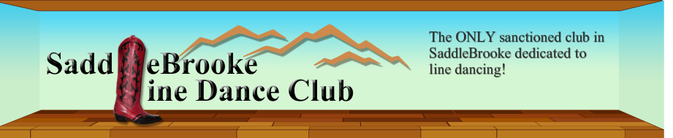

LINE DANCE ETIQUETTE

Please refrain from the following:
- Using scented products.
- Carrying beverages onto the dance floor.
- Standing on the floor to talk during a walkthrough or teach. Please move to the perimeter of the room and keep the conversation brief and low, or go to another room.

- Crowding an existing line of dancers. If possible start another line.
- Walking through a line of dancers to cross the floor - always walk around the floor or wait.

- Please be mindful of your space, especially when dancing near beginners. If a collision should occur, be courteous and apologize, no matter who was at fault.

FINALLY, KEEP SMILING, LAUGHING AND ENJOY YOURSELVES!

