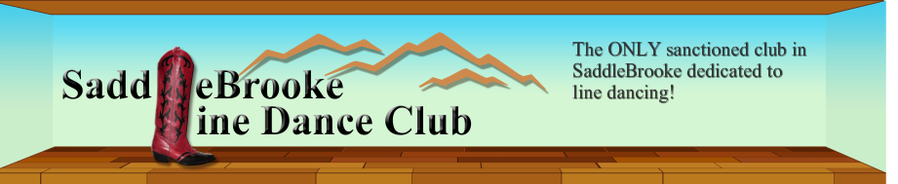
BOARD OF DIRECTORS
2016 Committee Accomplishments

Dance Committee – Krisse Arthur
- This year we created a Rotation Program System for each level. We now cycle through every Dance/Song combination on a systematic basis, producing specialized and varied programs for all of our club’s program days.
- Stats for the 2016 Club Year March 2016 thru January 2017 (11 months)
  - 9 dances were archived
  - 11 new dances were added to the Club Dance Repertoire, now totaling 82 dances
    - About Feelings F
    - Ain’t Misbehavin’ S,F
    - Bendito Rumba W,S,F
    - Better When I’m Dancin’ S,F
    - Gypsy Queen F
    - Keep My Kool S,F
    - Smells Like Trouble W
    - Not Going Home F
    - Stitches W,S,F
    - Tango Pierre S,F
    - What If Waltz W,S,F
    - Ticket to the Blues (2015) was taught on Sunday & Friday this year
  - Level 1 (Wed) 4 dances added Total Dance Count = 43
  - Level 2 (Sun) 8 dances added Total Dance Count = 72
  - Level 3 (Fri) 11 dances added Total Dance Count = 78

Leader Instruction Committee – Claudia Rigg
- I encouraged members throughout the year to step forward to lead dances from the beginner’s workshop.

Music Committee –Dorothy Wood
- Provided music and playlists for club socials, outside events and performances; including Dance-a-thon, Garden Party, Amber Lights Performance, 4th of July Performance, Sunliners Co-Social, Fiesta, Halloween, Potluck and Christmas Party
- Reviewed music for experimental dances brought to Dance Committee Workshops to identify out-of-phrase music or “events” (tags/restarts)
- Provided instructional versions of songs for new dances that were brought to our workshops and for officially teaching to our club members
- Researched and workshop-tested alternative songs for existing club dances. Confirmed count-ins, identified events, and made edits for speed and duration.
- Continued to assess, add, delete, and edit our current official SBLDC songs for the data base and program rotations. We now have over 300 songs in our data base
- Reviewed music selections and frequency for all three levels of the rotational dance system
- Added song and dance assignments to all four club iPads on a routine basis
- Managed, formatted, and sent out the playlists to program volunteers on a weekly basis

Program Committee – Linda Weiss/Mary Gajeske
- Thanks to all who volunteer to make our Sunday program work. It is more difficult with Connie gone because these same people are also putting together Friday programs. Sunday would not be a success without their help.

Social Committee – Lynne Kumza
- Sent get well & sympathy cards.
- Performances:
  - Amber Lights then ate lunch together at Outback
  - HOA1 July 4th celebration

- CC&C:
  - Oracle Inn
  - First Watch
  - Shop Till You Drop & lunch together at Cracker Barrel

- Parties: Luau
  - Garden Party
  - Ice Cream Social
  - Halloween
  - Pot Luck at Deb Adinolfi’s
  - Fiesta
  - Christmas

- Sharing Steps: I came up with the name of Sharing Steps.
    - Meetings with ladies from Rancho Vistoso to set up Sharing Steps
    - 2 Sharing Steps; one at Rancho Vistoso and one here in Saddlebrooke

- Three years ago when I became the Social Chair person, I started Chit Chat & Chow and also at the three levels of dance sessions, I made up “What Makes You Smile”.

Website Committee – Terri Gage
- Worked on becoming more proficient with the features of our website.
- The website documents were all updated to reflect the current information of our club.
- The Google Calendar was essential to provide updated program information and schedule changes in real time.
- Ensure that information was disseminated from committee members in a timely manner.
- Program line-ups were posted weekly for members.
- Addressed any changes or corrections requested by members.

